**DAILY ONLINE ACTIVITIES SUMMARY**

|  |  |  |  |  |  |  |  |  |
| --- | --- | --- | --- | --- | --- | --- | --- | --- |
| **Date:** | **25/06/2020** | | | | | **Name:** | **NAIPUNYA VINOD NAIK** | |
| **Sem & Sec** | **IV SEM & A SECTION** | | | | | **USN:** | **4AL18CS050** | |
| **Online Test Summary** | | | | | | | | |
| **Subject** | | **NO INTERNALS CONDUCTED** | | | | | | |
| **Max. Marks** | | **N/A** | | **Score** | | | **N/A** | |
| **Certification Course Summary** | | | | | | | | |
| **Course** | **1)** **DEEP LEARNING FOR BEGGINERS: NEURAL NETWORKS IN R STUDIO.**  **2) WEBINAR ON C++ PROGRAMMING** | | | | | | | |
| **Certificate Provider** | | | **1)UDEMY**  **2)AIET** | | **Duration** | | | **1)8 HRS**  **2)2 HRS** |
| **Coding Challenges** | | | | | | | | |
| **Problem Statement: 1)** [Write a C Program to reverse the rows in a 2d Array](https://github.com/orgs/alvas-education-foundation/teams/2nd-year/discussions/136). | | | | | | | | |
| **Status:- EXECUTED** | | | | | | | | |
| **Uploaded the report in Github** | | | | | **YES** | | | |
| **If yes Repository name** | | | | | <https://github.com/naipunya-naik/lockdown-coding/blob/master/C%20CODING/reverse%20matrix_25-06-2020.c> | | | |
| **Uploaded the report in slack** | | | | | **YES** | | | |

Online Test Details: (Attach the snapshot and briefly write the report for the same)

NO INTERNALS CONDUCTED

Certification Course Details: (Attach the snapshot and briefly write the report for the same).

CERTIFICATION COURSE NAME:- DEEP LEARNING FOR BEGGINERS: NEURAL NETWORKS IN R STUDIO.

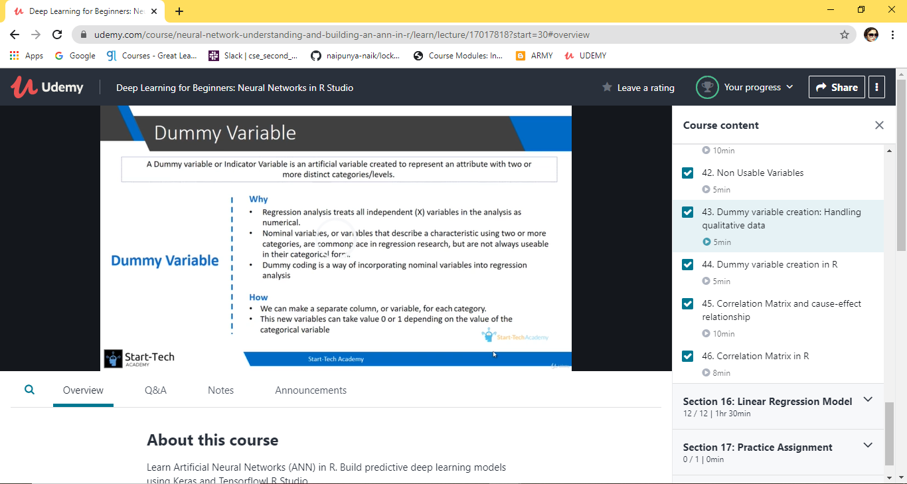

TOPICS LEARNT ON 25 JUNE 2020:-

* **Section 8: Tensorflow and Keras**
* **Section 9: R - Dataset for  
  classification problem**
* **Section 10: R - Building and training  
  the Model**
* **Section 11: The NeuralNets Package**
* **Section 12: R - Complex ANN  
  Architectures using Functional API**
* **Section 13: Saving and Restoring**
* **Section 14: Hyperparameter Tuning**
* **Section 15: Add-on 1: Data  
  Preprocessing**
* **Section 16: Linear Regression Model**
* **Section 17: Practice Assignment**
* **Section 18: Bonus Section**

CERTIFICATE OF THIS COURSE WILL BE PROVIDED SOON.

2) WEBINAR ON C++ PROGRAMMING

* CONDUCTED BY:- MS.SHRUTI .J.SHETTY,ASST.PROF,AIET
* DURATION:- 2 HRS
* FROM 9AM TO 11 AM
* 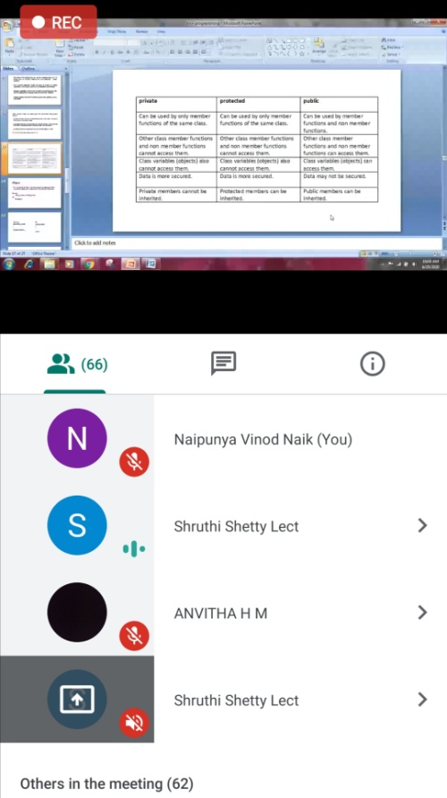
* THE QUIZ WAS CONDUCTED AFTER THE SESSION.
* NO.OF.QUESTIONS:-6
* TOTAL MARKS:- 30
* EACH QUESTION CARRIED 5 MARKS.

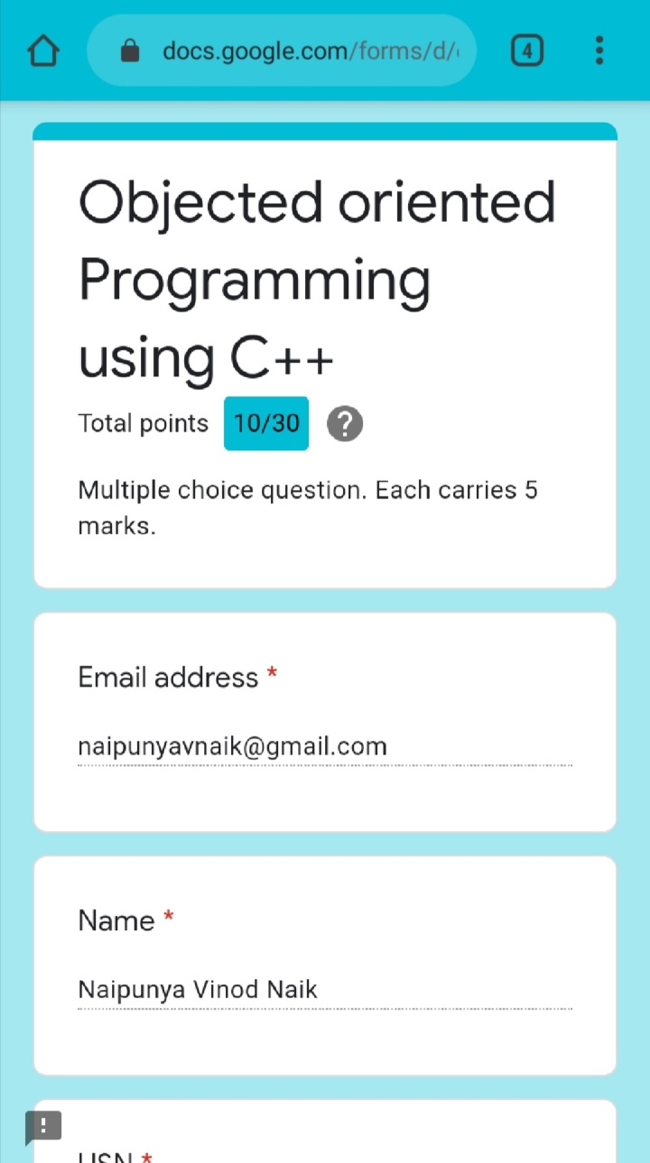

Coding Challenges Details: (Attach the snapshot and briefly write the report for the same)

[Write a C Program to reverse the rows in a 2d Array](https://github.com/orgs/alvas-education-foundation/teams/2nd-year/discussions/136)

Top of Form

Bottom of Form

|  |
| --- |
| Given a 2D array arr[][] of size M x N integers where M is the number of rows and N is the number of columns. The task is to reverse every row of the given 2D array.  **Example:**  **Input:** arr[][] = { {1, 2, 3}, {4, 5, 6}, {7, 8, 9} } **Output:** 3 2 1 6 5 4 9 8 7  **Input:** arr[][] = { {1, 2}, {4, 5}, {7, 8}, {9, 10} } **Output:** 2 1 5 4 8 7 10 9 |

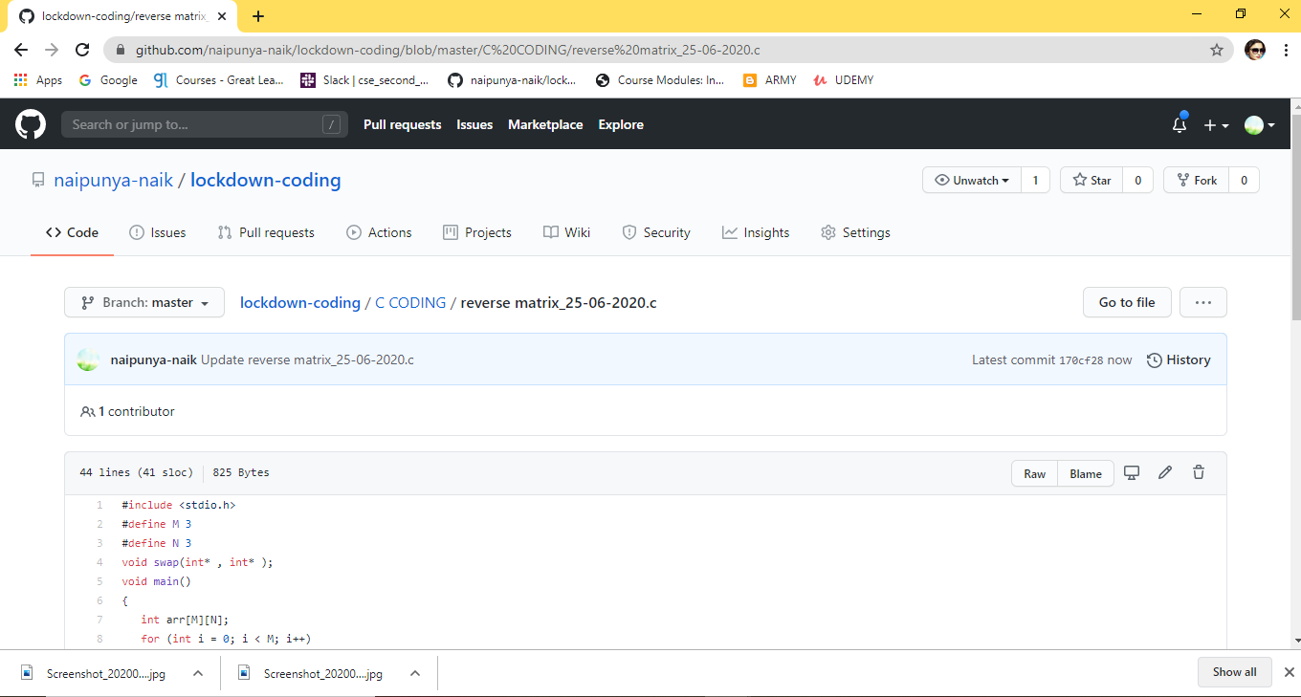

GITHUB REPOSITORY LINK:-

<https://github.com/naipunya-naik/lockdown-coding/blob/master/C%20CODING/reverse%20matrix_25-06-2020.c>